TASK 1: PYTHON FILE HANDLING & AUTOMATION

Student Details
Name: G HARINI
Course: B.Tech - Computer Science and Engineering
Domain: Python developer intern
Aim: The aim of this task is to implement Python file handling and automation using built-in modules. It demonstrates file operations such as create, read, write, rename, move, and delete, along with exception handling for safe execution of file operations.
Tools Used:
- Python 3.11
- VS Code (Code Editor)
- OS module (for file operations like rename, check, delete)
- Shutil module (for moving files between folders)
PROCEDURE:
Initialized the Python program and imported required modules.
Created a file and wrote sample data into it.
Opened and read the file to verify content.
Renamed the file using file handling functions.
Created a directory to organize files.
Moved the file into the created directory.
Performed cleanup by deleting the file.
Implemented exception handling for error control.
Code:
import os
import shutil

# 1. Write to file
with open("sample.txt", "w") as file:
file.write("Hello, this is a sample file.\n")
file.write("Python File Handling Task.\n")

print("File written successfully.")

# 2. Read file
with open("sample.txt", "r") as file:
content = file.read()

print("\nFile Content:")
print(content)

# 3. Append to file
with open("sample.txt", "a") as file:
file.write("This line is appended.\n")

print("Data appended successfully.")

# 4. Rename file (FIX)
if os.path.exists("renamed.txt"):
os.remove("renamed.txt")

os.rename("sample.txt", "renamed.txt")
print("File renamed successfully.")

# 5. Copy file
shutil.copy("renamed.txt", "copy.txt")
print("File copied successfully.")

Screenshots:(Code)
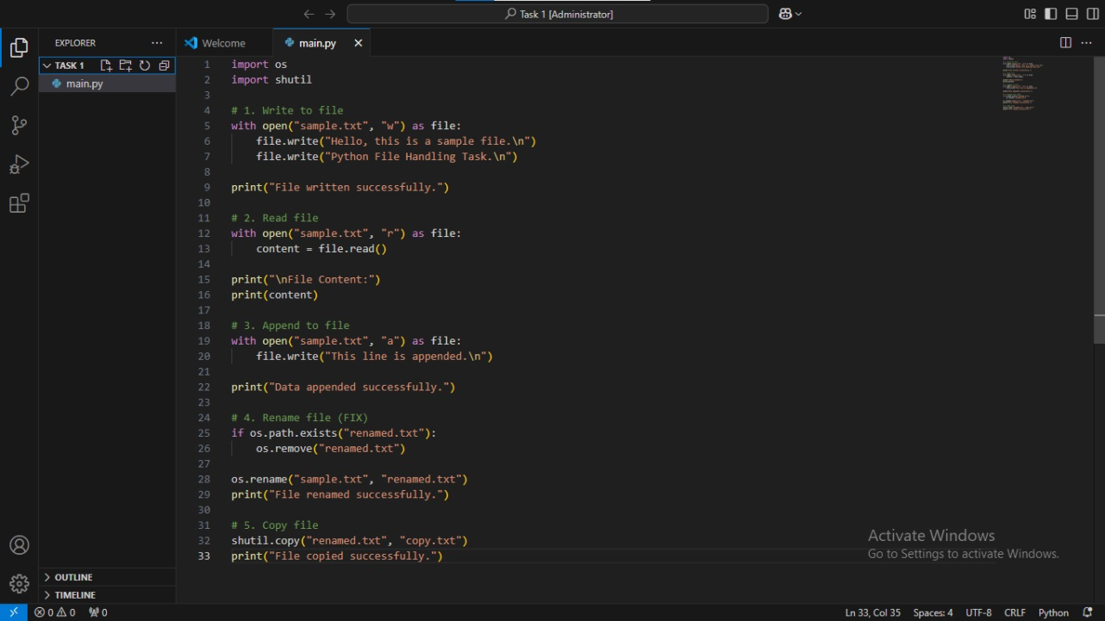
(Output) 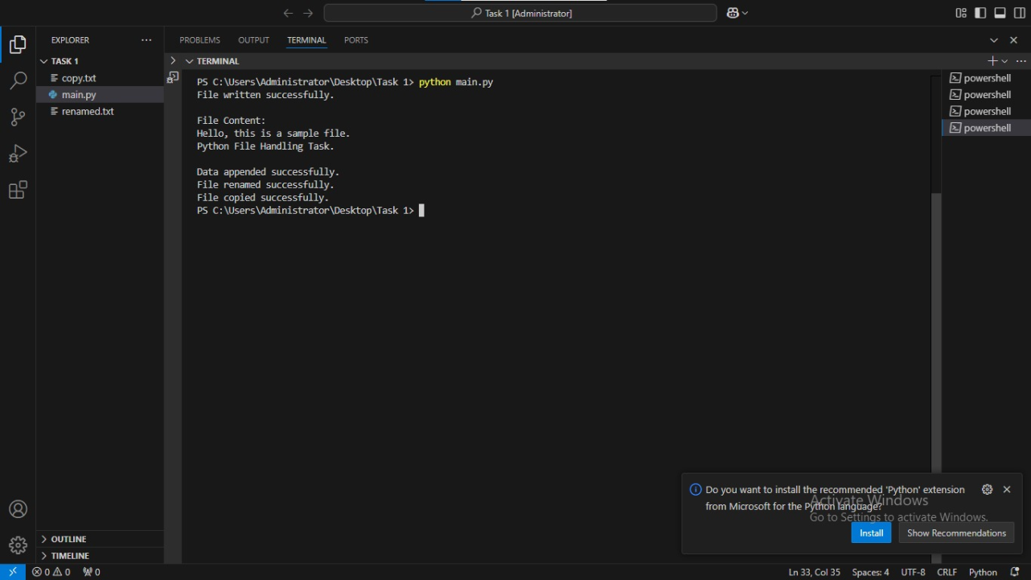

(System Proof)
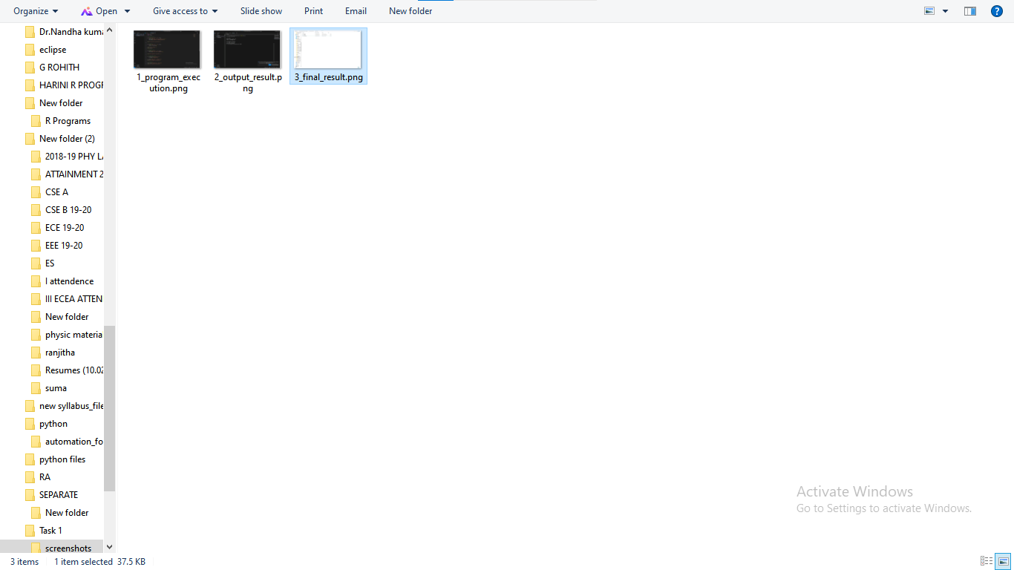
(Folder Structure)
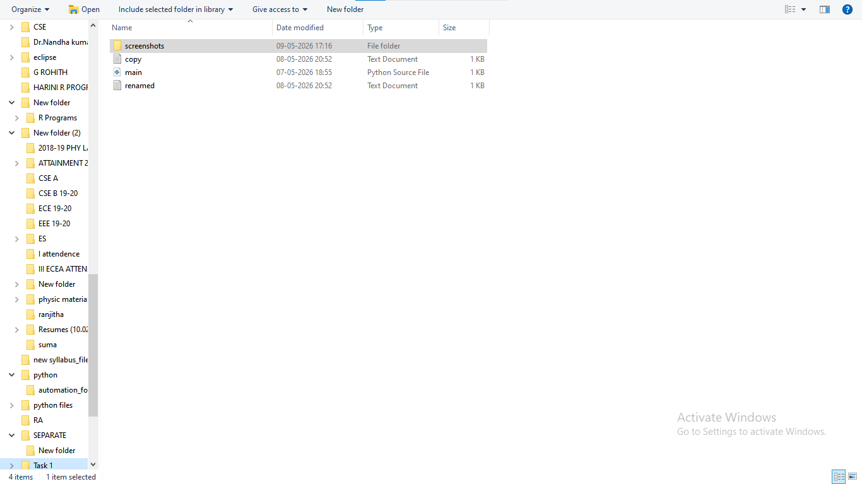

GitHub Link:
https://github.com/HariniG4107/python-internship-tasks.git

Conclusion: This task demonstrated how Python can be used to perform file handling and automate operations like creating, reading, renaming, moving, and deleting files. It also showed the use of exception handling to manage errors effectively. Overall, it provides a clear understanding of basic automation using Python.

